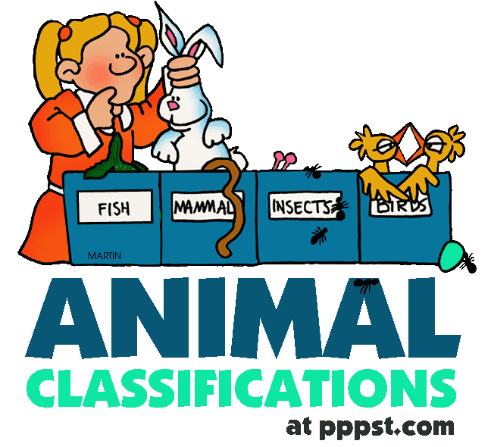
Joining Sentences – Classifying

Use an appropriate conjunctive to join the following sentences to make a compound sentence:

1. The first level of classification sorts living things into a small number of groups.
Each group has a very large number of organisms in it.

What is this first level called? _______________________________________

2. Organisms of the same species are the most similar.
They are not identical.

What does ‘they’ refer to? _________________________________________

3. Some of the kingdoms contain organisms that are familiar to you.
You may not know all of their names.

What are the five kingdoms? ________________________________________

________________________________________________________________

4. You should have no problem placing dogs in the animal kingdom.
Yeast or other microscopic organisms might prove more difficult to place.

What does microscopic mean? _______________________________________

________________________________________________________________

5. Fungi cannot make their own food.
They must feed on other organisms.

What does ‘they’ refer to? _________________________________________

6. Most organisms in the Protist kingdom live in water.
They are not harmful to humans.
Some cause disease.

What does ‘they’ refer to? _________________________________________

7. The kingdom Monera includes all the organisms known as bacteria.
Many people associate bacteria with disease.
Most bacteria are harmless.
Some are actually good for you.

8. People living in different areas often had different names for the same organisms.
This leads to confusion.

How have we overcome this problem? ________________________________

_______________________________________________________________

9. When scientists discover a new organism they observe it carefully.
They look for ways it is similar to species they know.
Then decide which group it belongs to.

Which two levels of classification are used to name organisms? ____________

_______________________________________________________________

